Project 2- Sales comparison by region

https://public.tableau.com/app/profile/akshay.hedau/viz/SalesComparisonbyRegion_16716099904280/SalesComparisonbyRegion

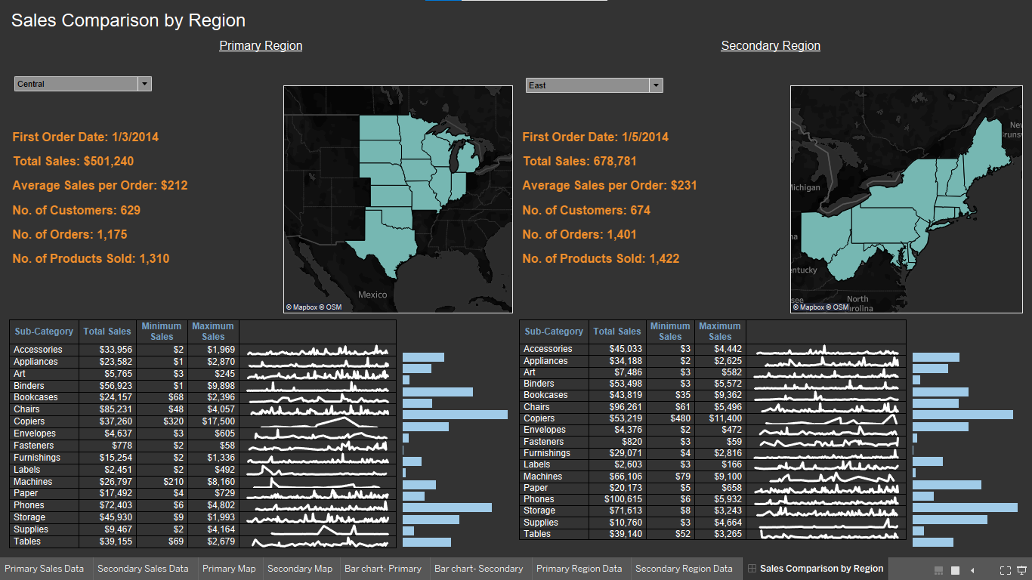

Above Dashboard gives detailed overview of sales in two regions. The data is shown side by side so that it is Easy to compare.
It also shows us minimum and maximum sales in sub-category, and shows us trend of sales on weekly basis.

Final Dashboard-

